Solr vs Elastic search


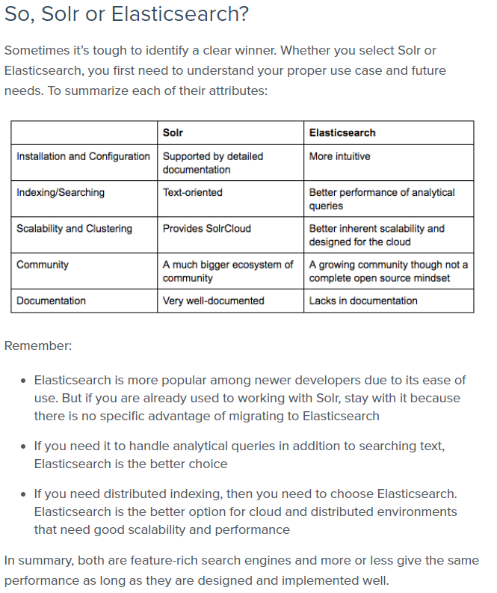
=====================================================================================

HBase vs Cassandra
Judging by how Cassandra and HBase organize their data models, they are both really good with time-series data: sensor readings in IoT systems, website visits and customer behavior, stock exchange data, etc. They both store and read such values nicely. Besides that, scalability is the property they both have: Cassandra – linear, HBase – linear and modular ones.
However, when it comes to scanning huge volumes of data to find a small number of results, due to having no data duplications, HBase is better. For instance, this reason applies to HBase’s ability to handle text analysis (based on web pages, social network posts, dictionaries and so on). Plus, HBase can do well with data management platforms and basic data analysis (counting, summing and such; due to its coprocessors in Java).
Cassandra is good for huge volumes of data ingestion, since it’s an efficient write-oriented database. With it, you’ll build a reliable and available data store. In addition, Cassandra enables you to create data centers in different countries and keep them running in sync. Besides, if you couple Cassandra with Spark, you can also achieve good scan performance.

But the main difference between applying Cassandra and HBase in real projects is this. Cassandra is good for ‘always-on’ web or mobile apps and projects with complex and/or real-time analytics. But if there’s no rush for analysis results (for instance, doing data lake experiments or creating machine learning models), HBase may be a good choice. Especially if you’ve already invested in Hadoop infrastructure and skill set.

Cassandra vs. HBase – a recap
Cassandra is a ‘self-sufficient’ technology for data storage and management, while HBase is not. The latter was intended as a tool for random data input/output for HDFS, which is why all its data is stored there. Besides, HBase uses Zookeeper as a server status manager and the ‘guru’ that knows where all metadata is (to avoid immediate cluster failures, when the metadata-containing master goes down). Consequently, HBase’s complex interdependent system is more difficult to configure, secure and maintain.

Cassandra is good at writes, whereas HBase is good at intensive reads. Cassandra’s weak spot is data consistency, while HBase’s pain is data availability, although both try to mitigate the adverse consequences of these problems. Also, both don’t stand frequent data deletes and updates.
So, Cassandra and HBase are definitely not twins but just two strangers with a similar hairstyle. To choose between the two, you should thoroughly analyze your tasks. And then, try to find a way to strengthen the database’s weak spots without affecting its performance.
---------------------------------------------------------------------------------------------------------------------
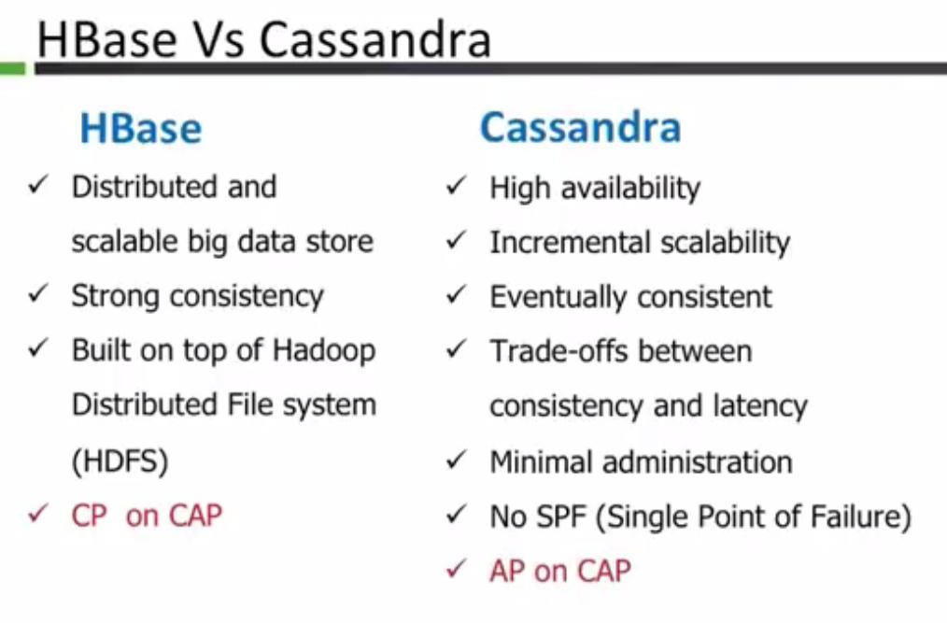
---------------------------------------------------------------------------------------------------------------------

HBase:
- HBase is based on Bigtable (Google).
- HBase particularly uses the Hadoop infrastructure (Zookeeper, NameNode, HDFS).
- HBase only supports ordered partitioning.
- Due to ordered partitioning, HBase will easily scale horizontally while still supporting Rowkey range scans.
- Triggers are supported by the coprocessor capability in HBase.

Cassandra:
- Cassandra is based on DynamoDB (Amazon).
- Cassandra does not support range-based row-scans which may be limiting in certain use-cases.
- Cassandra was initially developed at Facebook by former Amazon engineers.
- Cassandra does not support atomic compare and set.
- Cassandra will support read load balancing against a single row.
- Cassandra does not support co-processor-like functionality.

=====================================================================================
Orient vs Titan vs Neo4j

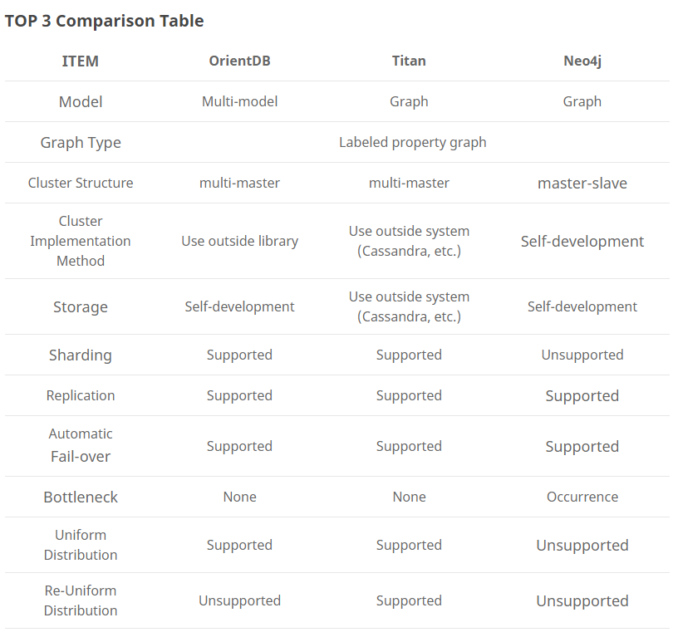

Neo4j It’s very well suited for storing graph types relationship information, such as a group of people and their relationships. Data modeling this sort of information in a traditional SQL database is a pain and inefficient. Using Neo4J allows for efficient modeling of data while providing rich querying capabilities using Cypher. It’s also a great fit for any programming language because of its support for REST API. It's less appropriate for any other data structure other than Graph data. So as with any DB, evaluate the data structure and query and if the querying revolves around relationships, then Neo4J is a fit. If there is more need for looking up individual nodes and their associated information, Neo4J might not be the most efficient solution in the market
Titan Titan is definitely a good choice, but it has its learning curve. The documentation may lack in places, and you might have to muster answers from different sources and technologies. But at its core, it does the job of storing and querying graph databases really well. Remember that titan itself is not the whole component, but utilizes other technologies like Cassandra, gremlin, tinker pop, etc. to do many other things, and each of them has a learning curve. I would recommend titan for a team, but not for a single person. For single developer, go with Neo4j.
https://www.trustradius.com/compare-products/neo4j-vs-titan-graph-database
====================================================================================

Thrift vs Avro vs Protocol Buffers

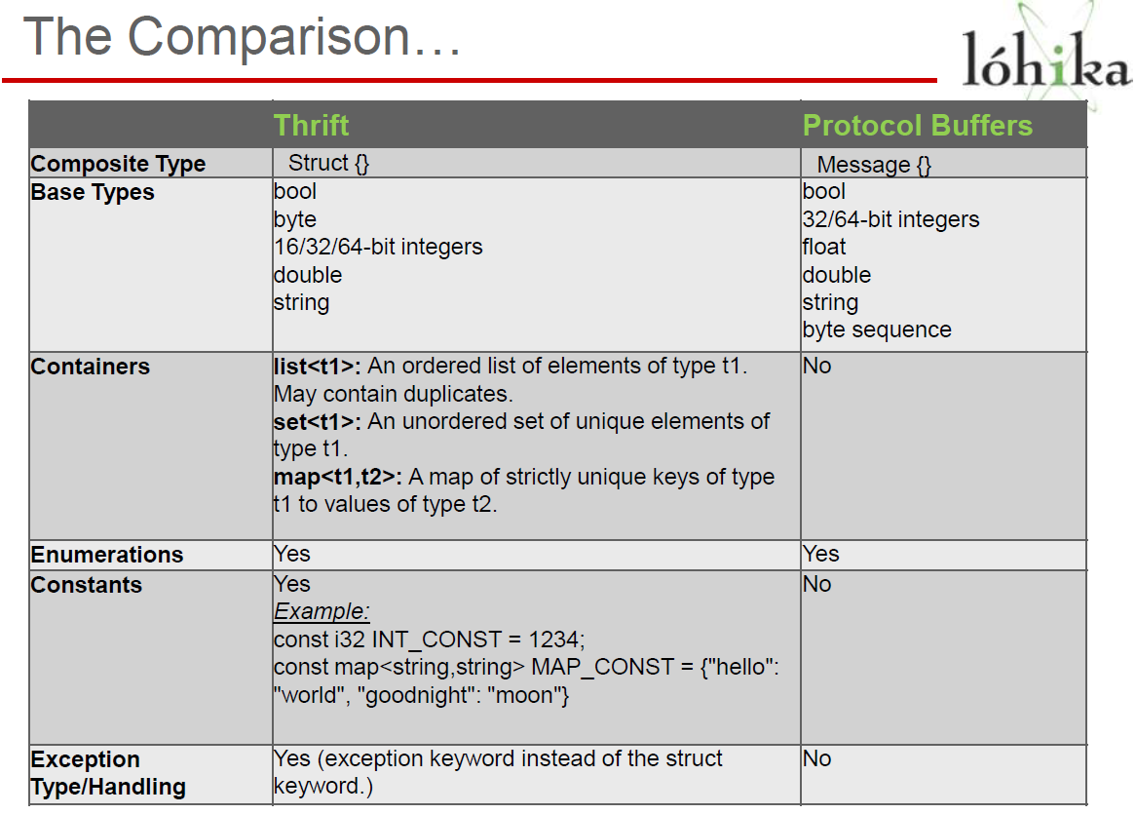

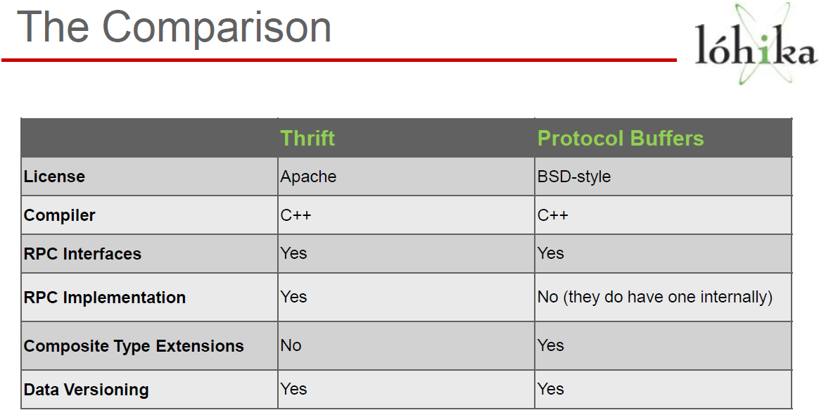

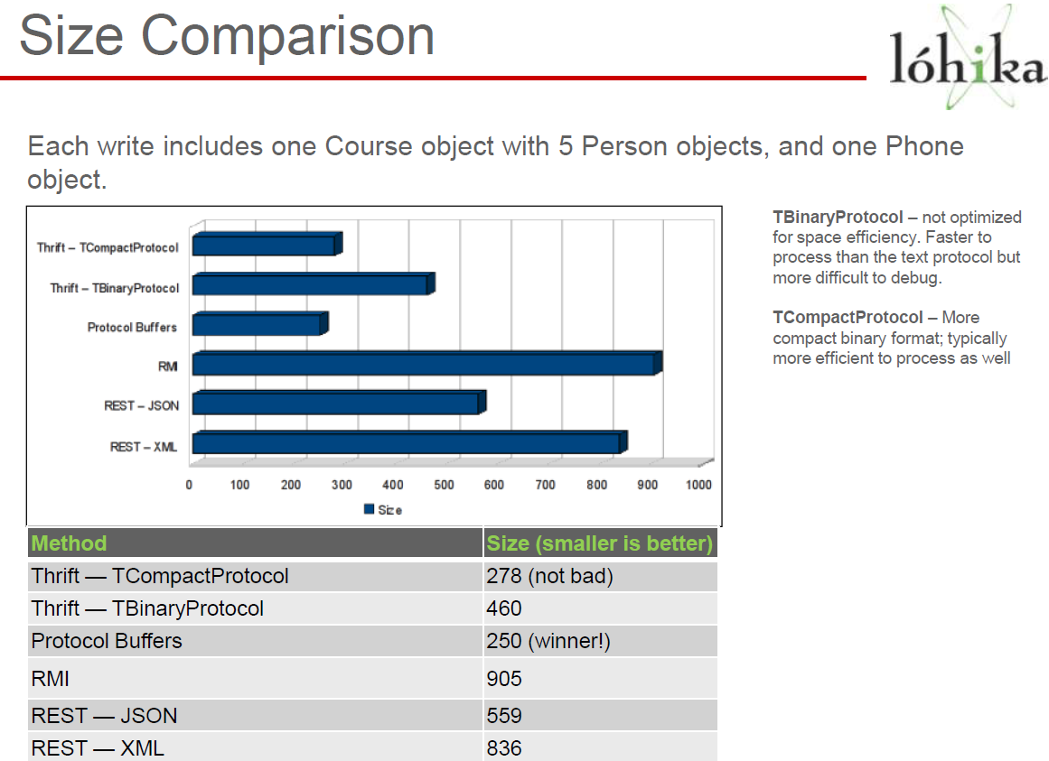

If you are looking for a battle-tested, strongly typed serialization format, then Protocol Buffers is a great choice. If you also need a variety of built-in RPC mechanisms, then Thrift is worth investigating. If you are already exchanging or working with JSON, then MessagePack is almost a drop-in optimization. And finally, if you like the strongly typed aspects, but want the flexibility of easy interoperability with dynamic languages, then Avro may be your best bet at this point in time.
NOTE Thrift & Avro both take slightly more space than Protocol Buffers. This might look insignificant, but using proto buffers we can save more space especially when EDC save millions
of Exchange Documents
https://www.igvita.com/2011/08/01/protocol-buffers-avro-thrift-messagepack/
------------------------------------------------------------------------------------------------------------------------------------------
Implementation: Protocol Buffers was a much cleaner implementation than Avro. Avro was messy with limited availability of online resources. Avro uses a JSON object in string form to represent a schema. Defining an Avro schema is cumbersome and difficult to maintain; as well as increasing the risk of runtime errors when the structure wasn’t quite right. The contract is not type safe, and it becomes very easy to set values against object fields of the wrong type. Such errors can only have been caught at runtime, rather than compile time.
Google’s Protocol buffer does not have such complexities. Protocol Buffers prompts the coder as soon as an error is reported through the protocol buffer compiler. Protocol Buffers allows null able fields (something that Avro doesn’t), which means that when protocol buffers is serializing, it will ignore fields that are null, and thus reduce the overhead of serializing irrelevant data (unlike Avro).
Winner – Google’s Protocol Buffers
Extensibility: Google’s Protocol buffer provides a much richer API for defining a data contract than Avro. Below is a list of features available to Protocol Buffers and not Avro:
- Declare nested types
- Define requires, repeated and optional fields
- Specify default values on fields
- Declare enumerations and set a fields default value from it
- Multiple message types in the same document
- Import other proto files
- Declare a range of field numbers in a message available for third party extensions (Extensions)
- Nested Extensions
- Define services
Winner – Google’s Protocol Buffers
Compatibility: Avro is only compatible with C, Java and Python, and hence restricts client technology candidate options, although they do plan for other technology languages.
Protocol Buffers is compatible with C, C++, Adobe Actionscript 3, Java and Python. As there is a C++ version is available, Microsoft Silverlight and WPF is therefore compatible with Google’s Protocol Buffers, but there are projects to port a Protocol Buffer compiler to C# and other technologies.
Winner – Google’s Protocol Buffers
http://www.sammur.com/?p=36
------------------------------------------------------------------------------------------------------------------------------------------
Thrift and Protocol Buffers are both great choices and there seems like no clear winner between them. Since they seem to have more in common than they do in conflict, it really comes down to real-world application-specific needs.
I'd choose Protocol Buffers over Thrift if:
- You're only using Java, C++ or Python. Experimental support for other languages is being developed by third parties but are generally not considered ready for production use
- You already have an RPC implementation
- On-the-wire data size is crucial
- The lack of any real documentation is scary to you
I'd choose Thrift over Protocol Buffers if:
- Your language requirements are anything but Java, C++ or Python. See above.
- You need additional data structures like Map and Set
- You want a full client/server RPC implementation built-in
- You're a Rock Star programmer that doesn't need documentation or examples

http://blog.mirthlab.com/2009/06/01/thrift-vs-protocol-bufffers-vs-json/
====================================================================================

